Book

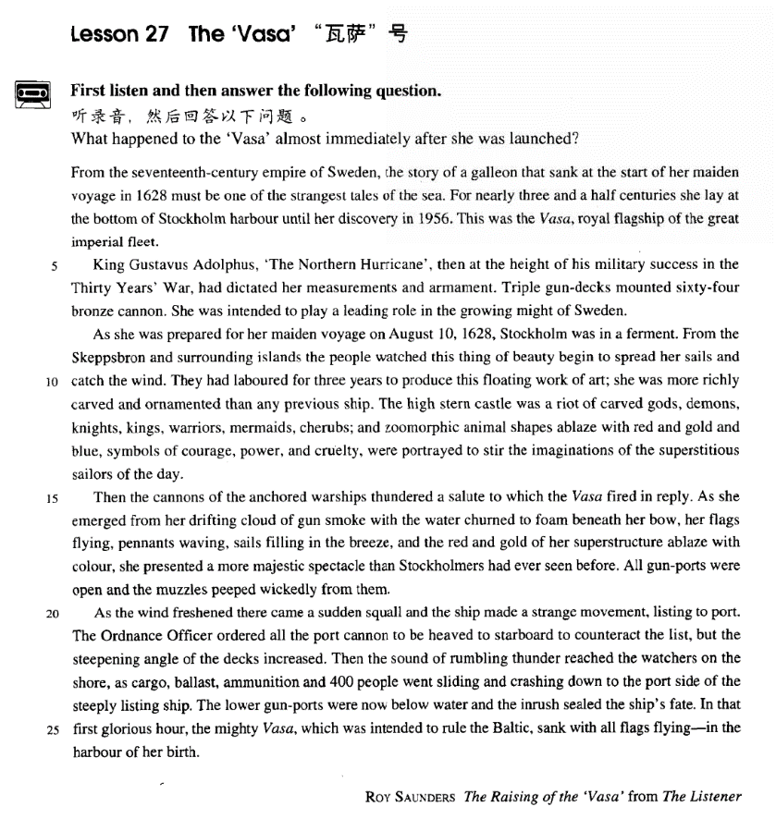

课文

From the 17th-century empire of Sweden, the story of a galleon that sank at the start of her maiden voyage in 1628 must be one of the strangest tales of the sea.

1628年，一艘大帆船在处女航时就沉没了，这个从容不迫7世纪瑞典帝国流传至今的故事无疑是航海史上最离奇的事件之一。

For nearly 3.5 centuries she lay at the bottom of Stockholm harbour until her discovery in 1956. This was the Vasa, royal flagship of the great imperial fleet. King Gustavus Adolphus 'The Northern Hurricane', then at the height of his military success in the 'Thirty Years' War, had dictated her measurements and armament.

这艘大船在斯德哥尔摩港口的海底躺了将近几年来个世纪之后，直到1956年才被发现。这就是“瓦萨”号，帝国大舰的皇家旗舰。当时号称“北方飓风”的国王古斯夫斯.阿道尔弗正处在“三十年战争”的军事鼎盛阶段，他亲自规定了这艘船的规模和武器配备。

Triple gun-decks mounted 64 bronze cannon.

3层的火炮甲板上装着64门青铜加农炮，

She was intended to play a leading role in the growing might of Sweden.

目的就是要在不断增长的瑞典势力中起主导作用。

As she was prepared for her maiden voyage on August 10th, 1628, Stockholm was in a ferment.

1628年8月10日，“瓦萨”号准备首航时，斯德哥尔摩一片欢腾。

From the Skeppsbron and surrounding islands the people watched this thing of beauty begin to spread her sails and catch the wind.

人们从斯开波斯布朗和周围的岛屿前来观着这艘美丽的战船扬帆起航，乘风前进。

They had laboured for three years to produce this floating work of art;

瑞典人辛辛苦苦干了3年才建成这件水上艺术品，

she was more richly carved and ornamented than any previous ship.

它比以往任何船只雕刻得都更加精美，装饰得都更加华丽。

The high stern castle was a riot of carved gods, demons, knights, kings, warriors, mermaids, cherubs; and zoomorphic animal shapes ablaze with red and gold and blue, symbols of courage, power, and cruelty,

高耸的船楼上雕刻了令人眼花缭乱的神仙、妖魔、骑士、国王、武士、美人鱼和小天使，还有用红色、金黄色、蓝色绘制的光彩夺目的兽形图案，象征着勇敢、力量和残暴，

were portrayed to stir the imaginations of the superstitious sailors of the day.

以激起汉时崇尚迷信的水手们的想像。

Then the cannons of the anchored warships thundered a salute to which the Vasa fired in reply.

这时，停泊在港口的其他战船向“瓦萨”号鸣炮致礼，“瓦萨”号也鸣炮回礼。

As she emerged from her drifting cloud of gun smoke with the water churned to foam beneath her bow, her flags flying, pennants waving, sails filling in the breeze, and the red and gold or her superstructure ablaze with colour, she presented a more majestic spectacle than Stockholmers had ever seen before.

当“瓦萨”号从弥漫的礼炮烟云中出现时，船头下浪花加溅，舰旗迎风招展，三角旗随风飘动，微风鼓起风帆，金碧辉煌的船楼闪耀着灿烂的色彩。“瓦萨”号展现的壮观景象是斯德哥尔摩人从未见过的。船上的炮眼开着，炮口虎视眈眈地向外窥视着。当风力增强时，突然刮来一阵大风，“瓦萨”号奇怪地摇晃了一下，便向左舷倾斜。

All gun-ports were open and the muzzles peeped wickedly from them. As the wind freshened there came a sudden squall and the ship made a strange movement, listing to port. The Ordnance officer ordered all the port cannon to be heaved to starboard to counteract the list but the steepening angle of the decks increased. Then the sound of rumbling thunder reached the watchers on the shore,

炮长命令把左舷上所有大炮搬到右舷上来以抵消船的倾斜，但甲板的倾斜度仍在增加。当物口、压舱物、弹药和400个人轰地一声滑向陡斜的左舷时，岸上的观众听到了雷鸣般的轰响。

as cargo, ballast, ammunition and 400 people went sliding and crashing down to the port side of the steeply listing ship. The lower gun-ports were now below water and the inrush sealed the ship's fate. In that first glorious hour, the mighty Vasa, which was intended to rule the Baltic, sank with all flags flying -- in the harbour of her birth.

下层炮眼已淹没在水里，涌进船舱的水给“瓦萨”号带来了难以逃脱的厄运。就这样，想要统治波罗的海的大型战舰“瓦萨”号，在它壮丽的起航时刻，带着全身飘扬的彩旗，沉没在了它诞生的港口。

词汇讲解

Lesson 27 The 'Vasa'

imperial [ɪm'pɪəriəl]

adj. 帝国的，帝王的，皇帝的

imperial adj. relating to an empire or to the person who rules it 帝国的， 帝王的，皇帝的

the imperial family the Imperial Palace

Britain's imperial expansion in the 19th century imperialism n. 帝国主义

the age of imperialism

imperialist n. 帝国主义者 adj. 帝国主义的

The developed nations have all benefited from their imperialist exploitation.

All the imperialist schemes and intrigues are doomed to failure. hurricane ['hʌrɪkən]

n. 飓风

hurricane n. a violent storm with very strong winds, especially in the western Atlantic Ocean（大西洋西海岸的）飓风

hurricane n.（大西洋西海岸的）飓风

typhoon n.（太平洋西海岸的）台风cyclone n. 特大的破坏性的暴风squall n. 突然刮起的狂风

tornado n. 龙卷风

dust devil n. 小规模的尘暴，尘旋风

blizzard n. 特大暴风雪snowstorm n. 暴风雪thunderstorm n. 大雷雨，雷暴windstorm n. 风暴

sandstorm n. 沙尘暴

might [maɪt]

n. 力量，威力，权力

might n. [U] great strength or power 力量，威力，权力

I pushed the rock with all my might.

We fear the military might of the enemy.

mighty adj. very strong and powerful, or very big and impressive 强大的，有力的，宏伟壮观的

Even a mighty express train can be held up by signals.

In that first glorious hour, the mighty Vasa, which was intended to rule the Ba tic, sank with a f a s f in ―in the harbour of her birth.

almighty adj. 全能的

God Almighty / Almighty God

zoomorphic [7zəʊə'mɔ:fɪk]

adj. 动物形状的，兽形的

zoomorphic adj. having the form of an animal 动物形状的，兽形的

a zoomorphic deity

zoo anima morph form ic zoo o o stud n. 动 物 学zoological adj. 动物学的

amorphous a not adj. 无定形的

metamorphosis meta chan e n. 变 形

po morphous po man adj. 多种形态的

majestic [mə'dʒestɪk]

adj. 宏伟的，壮观的，壮丽的

majestic adj. very big, impressive, or beautiful 宏伟的，壮观的，壮丽的

The great ship looked majestic in her new colours.

This lovely village is surrounded by majestic mountain scenery.

maj / max reat

majesty n. 威严，庄严；陛下

majestic adj. 宏伟的，壮观的，壮丽的major adj. 主要的，重要的，重大的majority n. 大多数

maxim n. 格言

maximal adj. 最大的

maximum adj. 最大的 n. 最大量，最大值

c imax c i ean n. 顶点，高潮

antic imax anti a ainst n. 突降，虎头蛇尾，令人失望的结局

port [pɔ:t]

n.（船或飞行器的）左舷

port n. the left side of a ship or aircraft when you are looking towards the front （船或飞行器的）左舷

to port

The plane tilted to port.

The ship was leaning over to port.

As the wind freshened there came a sudden squall and the ship made a strange movement, listing to port.

port 左舷 starboard 右舷

rudder 舵 anchor 锚

mast 桅杆 deck 甲板

hull 船体 cabin 船舱

bow 船头 stern 船尾

From the seventeenth-century empire of Sweden, the story of a galleon that sank at the start of her maiden voyage in 1628 must be one of the strangest tales of the sea.

empire emperor empress kingdom king queen city-state prince princess

Whenever the Italian city-states were at war with each other, Hawkwood used to hire his soldiers to princes who were willing to pay the high price he demanded.

galleon n. a large sailing ship used mainly by the Spanish from the 15th to the 17th century （15 至 17 世纪的）西班牙大帆船

maiden n. 少女，未婚女子

maiden voyage / flight / work …

= first voyage / flight / work …

The tragic sinking of this great liner will always be remembered, for she went down on her first voyage with heavy loss of life.

virgin land / forest …

tale n. a story, esp. one which might be invented or difficult to believe 故事，传奇

For nearly three and a half centuries she lay at the bottom of Stockholm harbour *until her discovery in 1956*.

指 车、船、祖国 时常用 she

What’s wron with m car? she won’t start. China has done what she promised to do.

She was carrying 1,316 passengers and crew of 891.

She stands on dry land and is visited by thousands of people each year. The Karen had been sailing in a convoy to Russia when she was torpedoed by an enemy submarine.

lie lay lain

lay laid laid

造句：在将近两个半小时里她躺在血泊之中，直到上午八点被人发现。For nearly two and a half hours she lay in a pool of blood until her discover at 8 o’c ock a.m.

造句：在一个多世纪的时间里中国人民生活在半殖民地半封建社会， 直到 1949 年中华人民共和国成立。

For more than a century the Chinese people lived in the semi-colonial and semi-feuda societ unti the foundation of the Peop e’s Repu ic of China in 1949.

This was the Vasa, royal flagship of the great imperial fleet. the Vasa

the Cutty Sark

The loss of the Titanic

flagship n. the most important ship in a group of ships belonging to the navy 旗舰

fleet n. group of warships, submarines, etc. under one commander 舰队

George W. Bush, President of the United States Who is caption of the team?

King Gustavus Adolphus, 'The Northern Hurricane', *then at the height of his military success in the Thirty Years' War*, had dictated her measurements and armament.

Gustavus Adolphus (1594-1632) king of Sweden whose victories in battle made Sweden a European power; his domestic reforms made Sweden a modern state; in 1630 he intervened on the Protestant side of the Thirty Years’ War and was ki ed in the att e of Lützen.

e at the hei ht of one’s success / fame / powers etc: to be more successful, famous etc than at any other time

The Beatles were at the height of their fame.

Thirty Years' War: A series of wars in central Europe beginning in 1618 that stemmed from conflict between Protestants and Catholics and political struggles between the Holy Roman Empire and other powers. It ended with the Peace of Westphalia (1648).

dictate v. to give orders, or state sth. exactly, with total authority 指定The UN will dictate the terms of troop withdrawal from the region. measurement n. [C, usually pl.] the length, height etc of something 尺寸Take measurements of the room before you buy any new furniture. armament [U] process of equipping military forces for war 武装

Triple gun-decks mounted sixty-four bronze cannon.

mount v. to fix sth. into position on sth., so that you can use it, look at it or study it 将某物固定住（以备使用、展示或研究）

mount sth. (on / onto / in sth.)

The specimens were mounted on slides. The diamond is mounted in gold.

a wall-mounted electric fan

bronze brass copper

cannon n. (复数cannon 或cannons) a large heavy powerful gun that was used in the past to fire heavy metal balls（发射实心金属炮弹的旧式）大炮

She was intended to play a leading role in the growing might of Sweden. intended adj. planned or designed for a particular purpose or person 为了……而计划或设计的

be intended for … / to do …

The book is intended for children.

The age limit is intended to guarantee that not only past work is rewarded. The Fields Medal is also intended to encourage the winners to make further contributions.

As she was prepared of her maiden voyage on August 10, 1628, Stockholm was in a ferment.

ferment n. [U, sing.] a situation of great excitement or trouble in a country, especially caused by political change 激动不宁，动荡不安

The whole country has been in a state of political ferment for some

months.

From the Skeppsbron and surrounding islands the people watched this thing of beauty begin to spread her sails and catch the wind.

thing of beauty = beautiful thing

A ship with all of its sails spread is a gallant sight.

My heart has spread its sails to the idle winds for the shadowy island of Anywhere.

hoist / lower the sails set sail

The following week the 'Queen Elizabeth' set sail for New York.

Mrs Healy moved away like a ship in full sail (= with all its sails spread). catch the wind 兜住风

The sails are torn; they won't catch the wind.

You can not catch the wind in a net.

They had laboured *for three years* to produce this floating work of art; she was more richly carved and ornamented than any previous ship. labour / labor v. to work hard

Five generations of his family have labored as fishermen.

Three hours after the explosion, rescue teams were still laboring to free those trapped.

work of art n. 1. a painting, statue, etc.

A number of priceless works of art were stolen from the gallery. work of art n. 2. something that is attractive and skillfully made The bride's dress was a work of art.

richly adv. if something is richly decorated, it is decorated a lot, in a way that is beautiful

a richly carved ceiling

a table richly ornamented with carvings

a cloak richly embroidered with gold thread

The high stern castle was a riot of carved gods, demons, knights, kings, warriors, mermaids, cherubs; and zoomorphic animal shapes ablaze with red and gold and blue, symbols of courage, power, and cruelty, were portrayed to stir the imaginations of the superstitious sailors of the day.

be a riot of sth. (fml.) be full of a collection of a lot of different types of

the same thing 充满了，充斥着

The garden was a riot of colour.

The market was a riot of unfamiliar sounds and smells.

ablaze adj. 1. burning strongly with a lot of flames 熊熊燃烧的

Within minutes the whole house was ablaze.

ablaze adj. 2. very bright or colorful 光鲜的，明艳的

a aze with …

Her yard was ablaze with summer flowers.

The trees were ablaze with the colors of autumn. s m o of … ……的象征、标志

The dove is a symbol of peace.

The lion is the symbol of courage.

The cross is the symbol of Christianity.

portray v. to show sb./sth. in a picture; to describe sb./sth. in a piece of writing（以绘画或文字）描绘

The painting portrays the duke's third wife.

His war poetry vividly portrays life in the trenches.

Then the cannons *of the anchored warships* thundered a salute to which

the Vasa fired in reply.

We anchored (our boat) close to the shore.

Before she had anchored, the men from the boats had climbed on board

and the decks were soon covered with colourful rugs from Persia, silks from India, copper coffee pots, and beautiful hand-made silver-ware. salute n. 1. an official occasion when guns are fired into the air to show respect 鸣礼炮致敬

Bands played, and there was a 21-gun salute.

fire / thunder a salute fire a salute of ten guns

Then the cannons of the anchored warships thundered a salute to which the Vasa fired (a salute) in reply.

salute n. 2. an act of raising your right hand to your head as a sign of respect, usually done by a soldier to an officer 敬礼

give / return a salute

The soldier gave a salute and the officer returned it. in reply / response to sth.

I am writing in reply / response to your letter of June 12. In response to renewed pleadings, Bruce stopped.

造句：哨兵 (sentry) 向我们敬礼，我们挥手 (wave) 还礼。

The sentry gave us a salute to which we waved in reply.

As she emerged from her drifting cloud of gun smoke with the water

churned to foam beneath her bow, her flags flying, pennants waving, sails

filling in the breeze, and the red and gold of her superstructure ablaze

with colour, she presented a more majestic spectacle *than Stockholmers*

*had ever seen before*.

drift v. to move slowly on water or in the air 漂流，飘移

The boat drifted down the river.

Thick smoke from a forest fire drifted across the town.

cloud n. a large amount of smoke, dust, steam, etc. in the air 烟云，烟尘

cloud of dust / smoke / gas …

The hens darted away on all sides, raising a cloud of dust.

churn (up) v. if water, mud etc churns, or if something churns it, it moves about violently 翻滚，翻腾，汹涌奔腾

The water churned beneath the huge ship.

The sea was churned up by heavy winds.

foam n. [U] a mass of very small air bubbles on the surface of a liquid 泡沫

a glass of beer with a good head of foam

The breaking waves left the beach covered with foam. The ship's propeller churned the waves to foam.

The wind howled and churned up the water into swirling foam.

pennant n. long narrow flag tapering to a point, used on a ship for signaling or as identification （船上用作信号或识别标志的）长三角旗fill v. become full 充满

The hall soon filled.

The sails filled with wind.

superstructure n. the structural part of a ship above the main deck 甲板上部结构，船楼

All gun-ports were open and the muzzles peeped wickedly from them. gunport / gun-port n. 战舰上的炮门，炮眼

muzzle n. open end of a firearm, out of which the bullets, etc come 枪

口，炮口

peep v. to look at something quickly and secretly, especially through a hole or opening 窥视，窥探

We caught her peeping through the keyhole.

As the wind freshened there *came* a sudden squall and the ship made a strange movement, *listing to port*.

freshen v. (of the wind) become strong and cool （指风）变得强而凉

The wind will freshen tonight. a freshening onshore breeze

非be 动词的存在句型 existentia sentences with ver s other than ‘ e’

there 常与 be 动词之外的不及物动词 (come, go, arrive, follow, rise, exist, appear, remain, live, lie, stand, happen, occur 等等) 构成存在句， 以突出句末的主语。

There came to his mind her beautiful face.

There remains nothing more to be done. There followed an uncomfortable silence.

There rose in his imagination visions of a world empire.

Not long after this, there occurred a sudden revolution in public taste. Fortunately for me, as I was wondering what to do next, there appeared on the horizon a man on horseback, riding in my direction.

He made no other movement, but stood with his thumbs in his belt. discover …

→ make a discover of … descri e …

→ make a description of … investi ate …

→ make an investi ation of … summarize …

→ make a summar of … ana ze …

→ make an ana sis of … contri ute to …

→ make contri utions to … emphasize / stress …

→ lay / put emphasis / stress on …

understand …

→ have an understandin of … consider …

→ ive consideration to … o ject to …

→ have an o jection to …

list v. (of a ship) lean over to one side（指船）倾侧The ship lists to port.

The damaged vessel was listing badly.

The Ordnance Officer ordered all the port cannon *to be heaved to starboard to counteract the list*, but the steepening angle of the decks increased.

ordnance n. [U] large guns with wheels 大炮

Ordnance Officer n. 炮长，司炮

heave v. to push, pull, or lift a heavy object using a lot of effort 用力推、拖拽或提升重物

Alan heaved his suitcase onto his bed.

counteract v. to reduce or prevent the bad effect of something, by doing something that has the opposite effect 对抗，抵消

These exercises aim to counteract the effects of stress and tension.

steepen v. to become or to make sth. become steeper 使更陡峭

After a couple of miles, the slope steepened considerably.

Then the sound of rumbling thunder reached the watchers on the shore, as cargo, ballast, ammunition and 400 people went *sliding and crashing*

down to the port side of the steeply listing ship.

rumble v. make a deep heavy continuous sound 发出持续的低沉的声音

The machine rumbled as it started up. thunder rumbling in the distance

I'm so hungry my stomach's rumbling.

Then the watchers on the shore heard the sound of rum in thunder, … Then the sound of rum in thunder reached the watchers on the shore … We heard of the news that Beijing had won the right to host the 2008 Olympic Games.

The news came to us that Beijing had won the right to host the 2008 Olympic Games.

cargo n. [U and C] the goods that are being carried in a ship or plane（船

或飞机上的）货物

The captain knew that another attempt would be made later, for the sunken ship he was trying to find had been carrying a precious cargo of gold bullion.

ballast n. [U] heavy material that is carried by a ship to make it more

steady in the water（船中用以保持平稳的）压舱物

ammunition n. [U] supply of bullets, bombs, grenades, etc fired from weapons or thrown 弹药

go doing: to move in a particular way 以某种方式移动

The plate went *crashing* to the floor. The train went *chugging* up the hill. She went *sobbing* up the stairs.

Chairs and tables went *flying* into the arcade.

The lower gun-ports were now below water and the inrush sealed the ship's fate.

inrush n. [C usually singular] an occasion when sth. such as water or air enters a place quickly（水或空气的）涌入

an inrush of air / water

The inrush of fresh air filled the room.

sea s ’s fate / seal the fate of sb: to show or decide that sth. bad will definitely happen to someone 注定了……的厄运，使……在劫难逃The discovery of new evidence sealed his fate.

The outbreak of war sealed the government's fate.

Further floods may have sealed the fate of the few remaining villages.

In that first glorious hour, the mighty Vasa, which was intended to rule the Baltic, sank *with all flags flying―in the harbour of her birth*.

birth n. the time when something new starts to exist（新事物的）诞生the birth of a nation

The film gave birth to a TV show of the same name.